Online Application Manual for
SMU International Students

1. Create an I.D. and Password
You must create an ID and a password and log-in and fill out the online application.
- Click ‘Join Us’

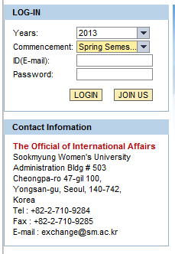

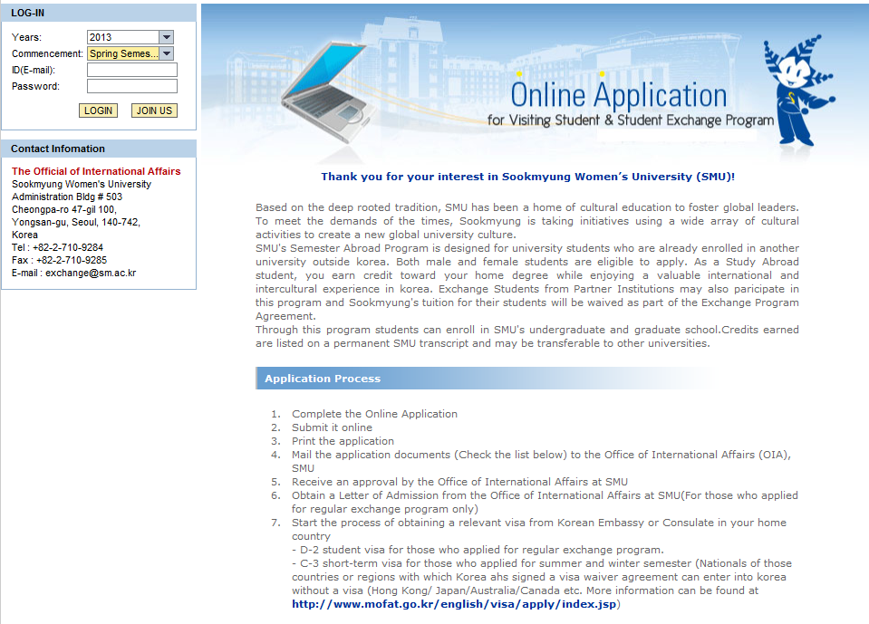

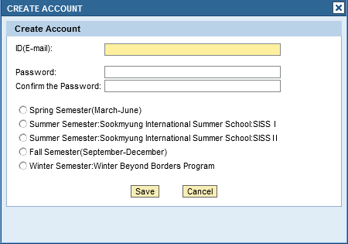
- Type your E-mail account which will be your I.D.

- Type your password
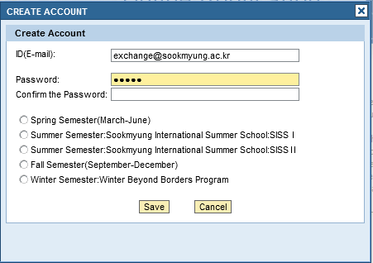
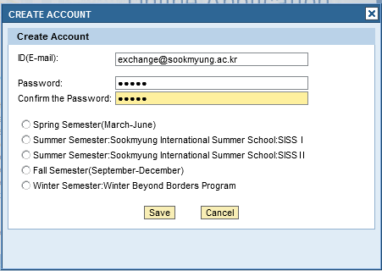
- Confirm your password by retyping the password
- Click one of the semester or programs you are willing to register
SISS I : Summer Semester International School I
SISS II: Summer Semester International School II
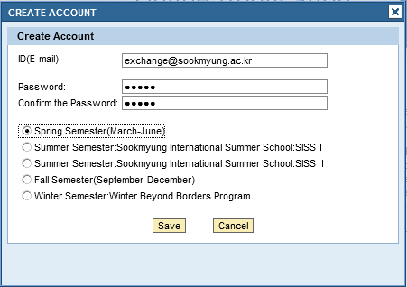

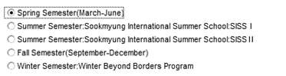

- Click Save
Your ID and password have been created successfully.

2. Log-in
① Click your “Years/Commencement” and then Log-in as below.
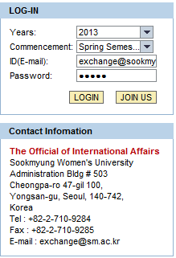

② Click “Application Form” Tab.
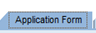
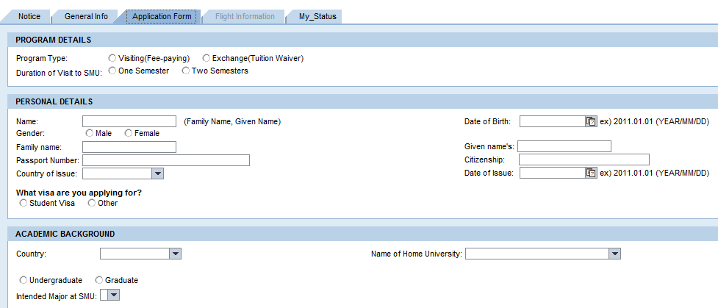

③ Fill in your information completely.
If you want to log out or revise it later, click ‘SAVE’.
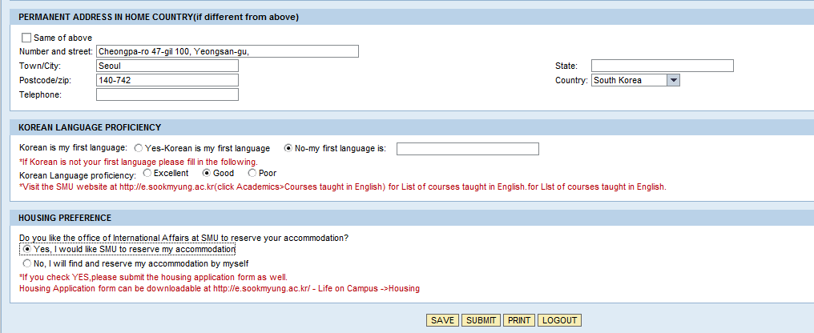
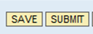
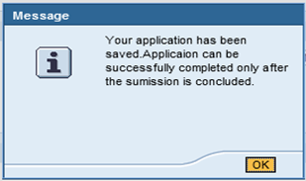
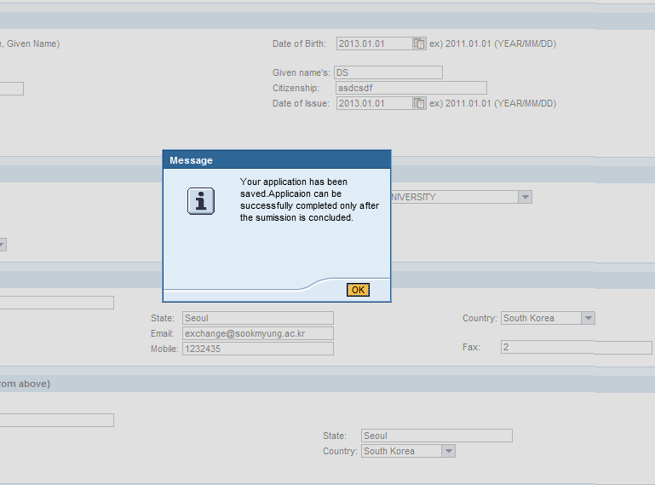
④ When finished, and click “Submit”, you’ll see the message below.

⑤ Click ‘PRINT’, and print the application form.
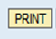
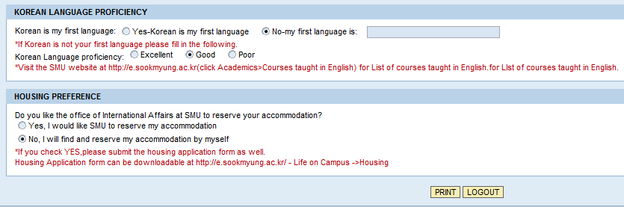
3. Print the application: Please print out the application form for application submission. You must submit the application form in print to your program coordinator with other documents!
Should you have any other problems, please contact us via exchange@sm.ac.kr or siss@sm.ac.kr

